OPENED: JANUARY 1, 2017
Company: FAUX SWEETS
3208 W 152nd Place Gardena, CA 90249
Phone: 310-210-9165
E-mail: fauxsweetsusa@gmail.com
ONLINE STORE: www.etsy.com/shop/myfauxsweets
FAUX SWEETS; ARTIFICIAL FOOD DECOR SPECIALIST
Los Angles, CA (11/06/2017) - FAUX SWEETS is a professional fake food and dessert decorator specializing in creating beautiful hand-made food, home and event décor. Originally, Faux Sweets was expected to be a niche-based business but it has blown to be a business with a hungry and demanding market. A lot of people have found the idea of recreating food and dessert as an art décor or sample to be showcased to be appealing.
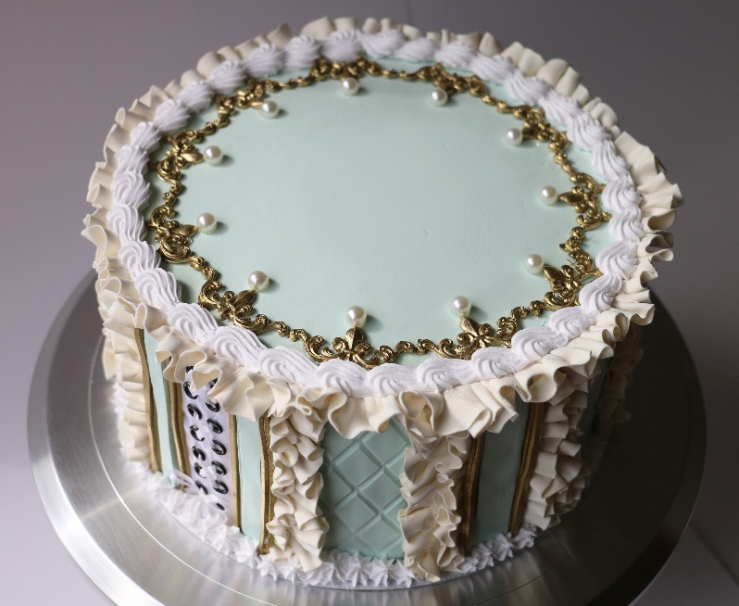
FAUX SWEETS was founded by Mae Hirota, a former banker now baker. She started this business as a cupcake shop on Etsy with no definite direction in mind. Today, the story is different and the business has grown larger than the original idea. The idea behind creating fake food samples was to be able to present food and dessert ideas as they should appear ideally.
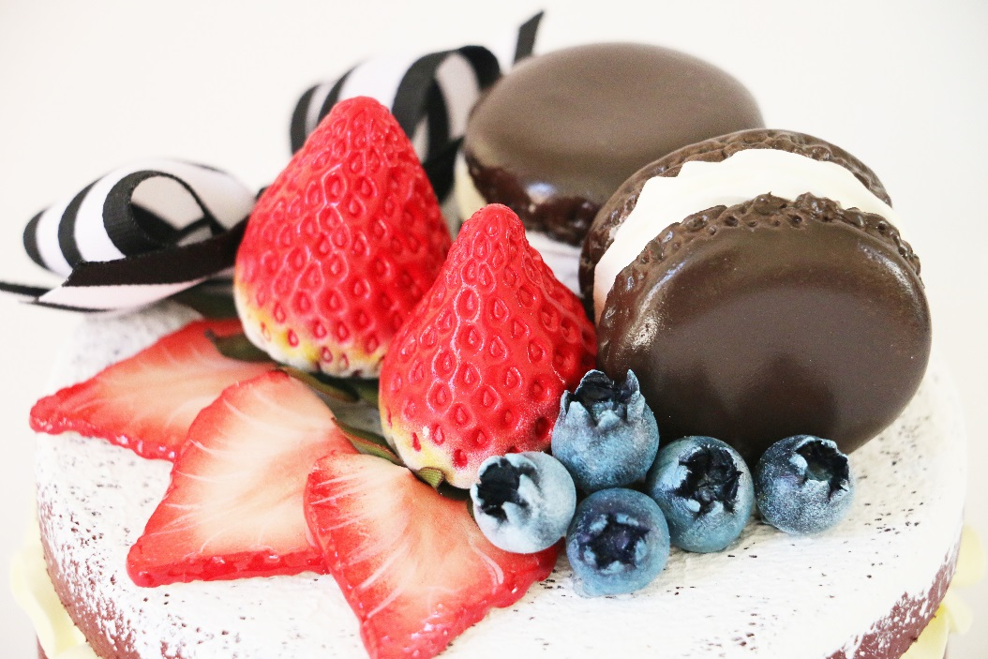
FAUX SWEETS has gained so much exposure that its 4 tier custom cake, 128 piece collection designed for CURIOUS, a London-based Event Agency will be showcased at the “let them eat cake” themed event at the prestigious SWAN Shakespeare‘s Globe, Winner of the 2017 London Venue Award.
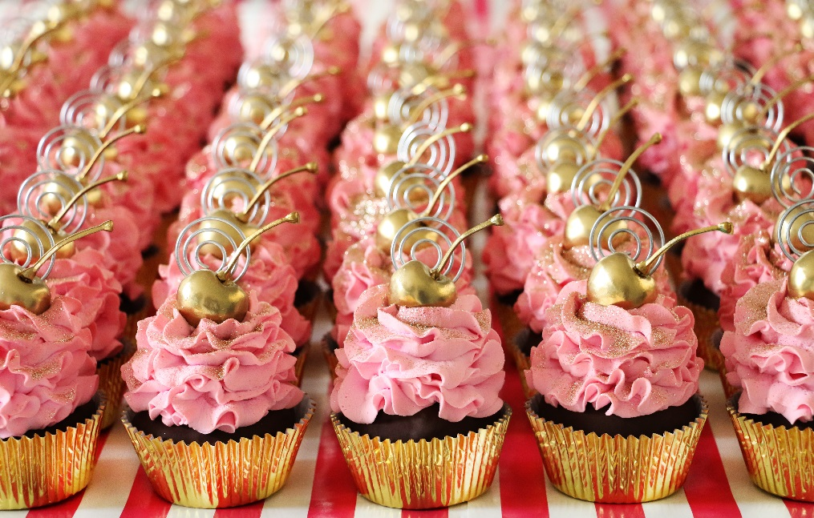
ABOUT FAUX SWEETS
Faux Sweet is a fake food and dessert shop created by Mae Hirota in January 2017. The company is based in Los Angeles, CA and has a web store on Etsy. Our sweets and desserts are built and designed using the same tools and equipment to ensure uniformity in design flow.
Faux Sweets received the “Rising Star” Award for the 2017 Harvest Festival and will be in Pomona, CA through 12/1~12/3; we also offer custom orders to clients on Etsy and you can place an order through domestic shipping through January 1, 2018.
You may reach out to us through the contact information by clicking here.

